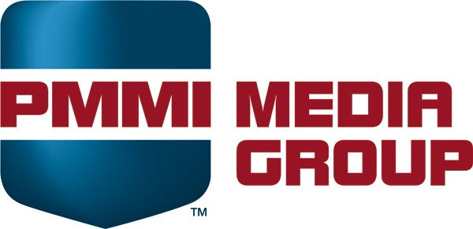

Monthly Sales Call
May 8, 2020
- Show update – MERIDETH
  - We are in a holding power trying to find out what the timeline is for phase 5 in Illinois
  - Looking at virtual in the meantime
  - Talking to insurance
  - Laura has a call with the board at the end of the month and will be presenting several options (one is moving to Orlando)
  - Tell people not to cancel – if THEY cancel, then they won’t get money back, but if WE cancel, then they will get money back
    - We could get one hall or all halls, depening on how many people we think we would have
- Sponsorship Update – ALLISON & JESSIE
  - Allison will email Wendy accounts that usually purchase sponsorships and haven’t yet (but right now everything is in a holding pattern)
  - Trying to push the last payment date to as late as we can
- Reserved dates in Trackvia – WENDY
  - You can check this report in TV to see if there are dates that are just reserved, not yet sold – you can reach out to the rep who has the reserved dates to see if you can have them
  - We will add a link to the product hub (but you will still have to log into Trackvia)
  - There are some bugs we are working on, but the view should still help you find dates
- Robotics Playbook delay – DAVE
  - Sarah is going to have to retool some of the content and this will cause a delay
  - Probably a month to 6 weeks delay
  - Will not affect the timing of the Design Build
  - First five are sold, but keep selling because they will cycle in and out
  - There will a link in the hub to the waiting list
- Isolating Pure Play Software companies for webinars – DAVE
  - A lot of software companies do webinars
  - We isolated these companies in Salesforce and Wendy sent a list last week
  - Call them up and tell them we have lower priced webinars
- Virtual Event Promotions Packages – DAVE/WENDY
  - A lot of companies are doing vitual tradeshows/events for themselves
  - We will brainstorm offline to try to come up with a plan
- Possible digital Cannabis audience – ALICIA
  - Via Bombora, we think we may have a way to reach our cannabis audience digitally. Should have acutal numbers soon.
- Product hub – ALICIA
  - Process and Video tabs
  - Blank tabs will no longer show up
  - Ongoing work and feedback welcome
- Converge
  - We are launching internally next week and we will look at the data and then officially launch in a couple of weeks
  - Dave is doing a webinar in June to explain
  - We will have a call with reps in the next week or two to do a walkthrough

